**Software Design Methodology**

Assignment No: 4

**Data Flow Diagram**

**ONLINE FOOD ORDER SYSTEM**



|  |  |  |
| --- | --- | --- |
| Project Group Information (TY-25) | | |
| Roll. No. | Gr. No. | Name |
| 22 | 11810820 | Shreya Hirapurkar |
| 58 | 11810499 | Vinayak Kokane |
| 60 | 11810970 | Dhanraj Kore |
| 63 | 11920122 | Vaishnavi kulkarni |

**LEVEL 0 DFD**

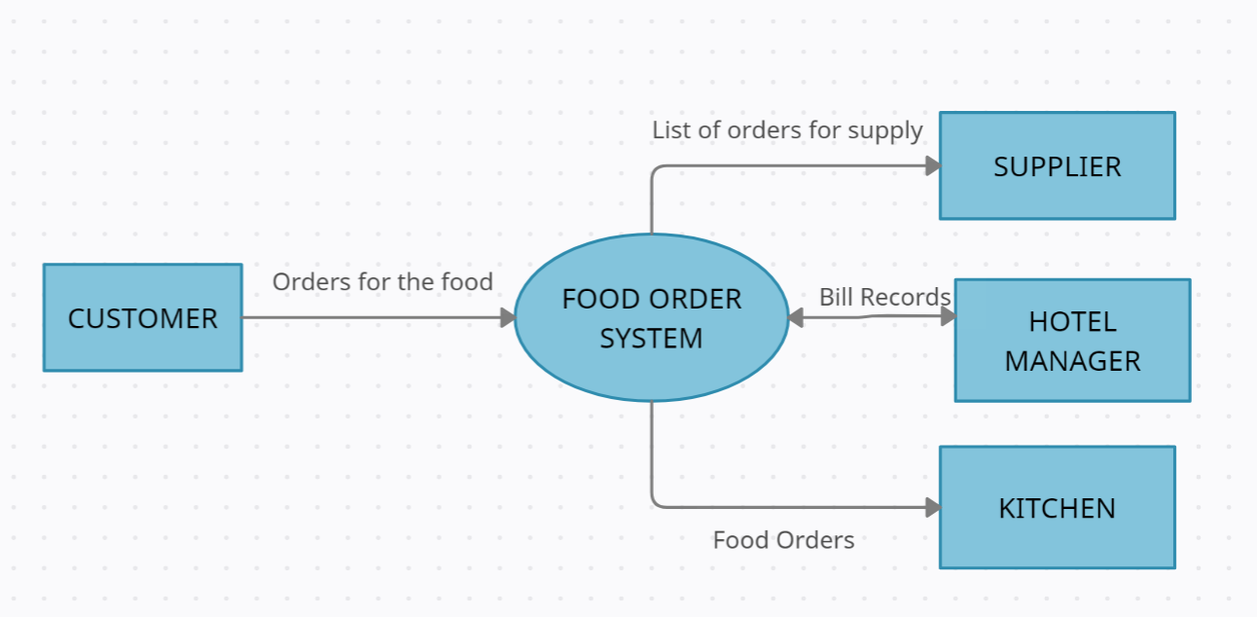

**LEVEL 1 DFD**

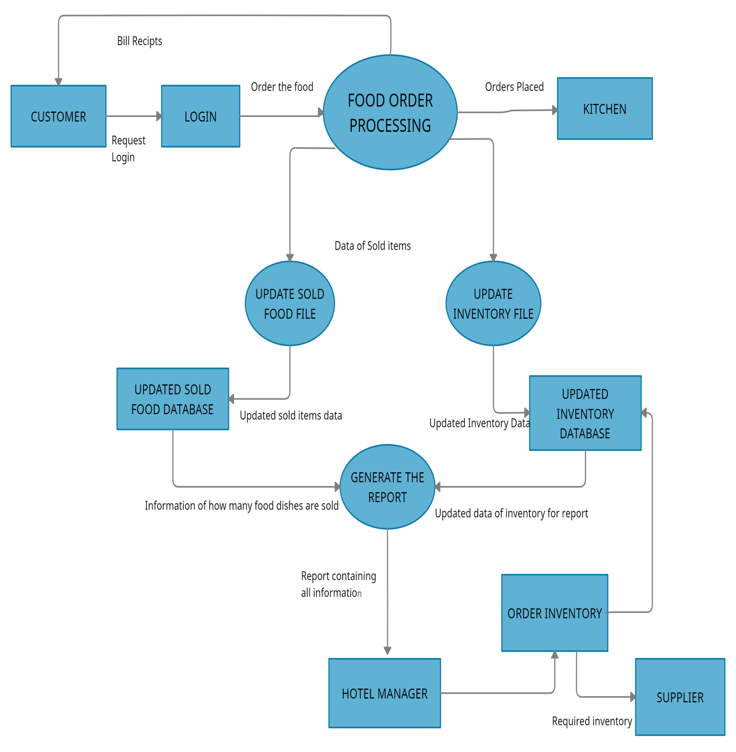

**LEVEL 2 DFD FOR LOGIN**

